PCBS
WALKTHROUGH CHECKLSIT
Adapted from Mid Atlantic PBIS Network Classroom Snapshots
How to use the Walkthrough Checklist:
- Nonevaluative Classroom Tool (buddy observations, peer observations, coach observations)
- Reflective Tool for Goal Setting/Action Planning
- TFI Walkthrough with External Evaluator
- Can be used all at once or by designated section
FOUNDATIONS: Setting
Components | No | Somewhat | Yes
Traffic patterns are clearly defined and allow movement without disrupting others
Desks and furniture arrangement are arranged so students can be seen at-all-times and the teacher has easy access to all areas of the classroom
Materials are clearly labeled, easily accessible, and organized for ease of use
FOUNDATIONS: Classroom Matrix
Components | No | Somewhat |  | Yes
Classroom rules and procedures aligned with school-wide expectations
Classroom rules and procedures are observable, measurable, positively stated, understandable, and prominently posted
Evidence that rules and procedures have been taught and continue to be reinforced (e.g., observation, ask teacher, student behavior)
PREVENTION PRACTICE: Supervision
Components | No | Sometimes |  | Frequently
The teacher moves and circulates through all parts of the classroom using close-proximity to students needing additional support
The teacher visually scans all parts of the classroom looking for both appropriate behaviors (provide acknowledgement) and inappropriate behaviors (close-proximity and error correction)
The teacher interacts frequently providing positive feedback, pre-correction, and correction. The teacher monitors and provides additional support to students needing help with academic and/or social behavior.
RESPONSE PRACTICE: Acknowledgement
Components | Tally Count |  | Total
Responses to Appropriate Behavior
General Responses:
Simple praise (good job), gesture (e.g., thumbs up) or a point used without naming the specific behavior. Directed to individual, group, or class.
Specific Response:
Behavior Specific Praise (teacher names the specific behavior). Directed to individual, group, or class.
Responses to Inappropriate Behavior
Verbal (redirect, reprimand), physical prompt, gesture, proximity control, look.
Ratio of Specific Responses (do not include general responses) to Responses to Inappropriate Behavior: |  |  | ___ / ___
PREVENTION PRACTICE: Opportunities to Respond
Observe and monitor the components of Opportunities to Respond during a 10-minute period or during predictable problematic times
 | Individual Responding | Unison Responding
Number of teacher behaviors (e.g., asking a question, making a request, presenting a task) soliciting an observable academic response from student(s) (verbal, written, gesture)
Types of OTRs used:
- Individual | - Unison Responding | - Mixed Responding | - Other Strategies
Comments:

Components for On-Task/Off-Task Behaviors for Academic Engagement: During an observation, observe each student momentarily (e.g., <1 second) and identify if student is on-task or off-task at that point in time. Mark a “+” for on-task behavior and a “-“ for off-task behavior. Observe and record observations until all boxes are completed. Repeat this process a few times during an observation (e.g., twice during a 15 minute observation).
1 | 2 | 3 | 4 | 5 | 6 | 7 | 8 | 9 | 10
11 | 12 | 13 | 14 | 15 | 16 | 17 | 18 | 19 | 20
21 | 22 | 23 | 24 | 25 | 26 | 27 | 28 | 29 | 30
31 | 32 | 33 | 34 | 35 | 36 | 37 | 38 | 39 | 40
41 | 42 | 43 | 44 | 45 | 46 | 47 | 48 | 49 | 50
51 | 52 | 53 | 54 | 55 | 56 | 57 | 58 | 59 | 60

1 | 2 | 3 | 4 | 5 | 6 | 7 | 8 | 9 | 10
11 | 12 | 13 | 14 | 15 | 16 | 17 | 18 | 19 | 20
21 | 22 | 23 | 24 | 25 | 26 | 27 | 28 | 29 | 30
31 | 32 | 33 | 34 | 35 | 36 | 37 | 38 | 39 | 40
41 | 42 | 43 | 44 | 45 | 46 | 47 | 48 | 49 | 50
51 | 52 | 53 | 54 | 55 | 56 | 57 | 58 | 59 | 60

1 | 2 | 3 | 4 | 5 | 6 | 7 | 8 | 9 | 10
11 | 12 | 13 | 14 | 15 | 16 | 17 | 18 | 19 | 20
21 | 22 | 23 | 24 | 25 | 26 | 27 | 28 | 29 | 30
31 | 32 | 33 | 34 | 35 | 36 | 37 | 38 | 39 | 40
41 | 42 | 43 | 44 | 45 | 46 | 47 | 48 | 49 | 50
51 | 52 | 53 | 54 | 55 | 56 | 57 | 58 | 59 | 60
Time 1: | Percentage of students on-task: | Instructional Activity:
Time 2: | Percentage of students on-task: | Instructional Activity:
Time 3: | Percentage of students on-task: | Instructional Activity:

Student/Classroom Observation & Analysis

Features
This application has many functions. It can collect observation data such as the amount of time an event occurs or the number of events observed. Observers can take notes following an observation and export the observation data to spreadsheet software to make graphic displays. Reliability can be calculated between observers and the export file can be imported into various software programs allowing for complex analyses.

SCOA can be use to collect information at multiple levels within the school setting ranging from whole school characteristics to individual student behaviors. Observation data can inform general school dynamics, teacher practices, change over time, and/or relationships among teacher and student behavior.

Download application
Download SCOA application through iTunes to the device. The device may be an iPhone, iPad or iTouch

Entering School, Teacher and Student information

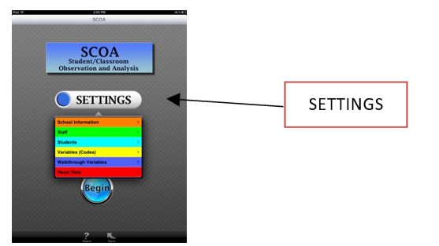
Step 1: Begin observations by setting up the device. Touch SETTINGS.

Step 2: Enter school, teacher, and/or student information

School Information is entered by ‘+’ adding a school. Include full name of the school, a unique school ID and name/state of the school district.

SAVE information.

Staff are entered by choosing the school and ‘+’ adding a staff member. Staff can be identified by name and ID or initials and a staff ID.

Characteristics of staff can be chosen from the options. Enter the staff email if you wish to forward findings from the observation to the teacher.

Students can be entered as members of classrooms. Choose the Staff and ‘+’ add the student by name and ID or initials. Characteristics of students can be chosen from the options.

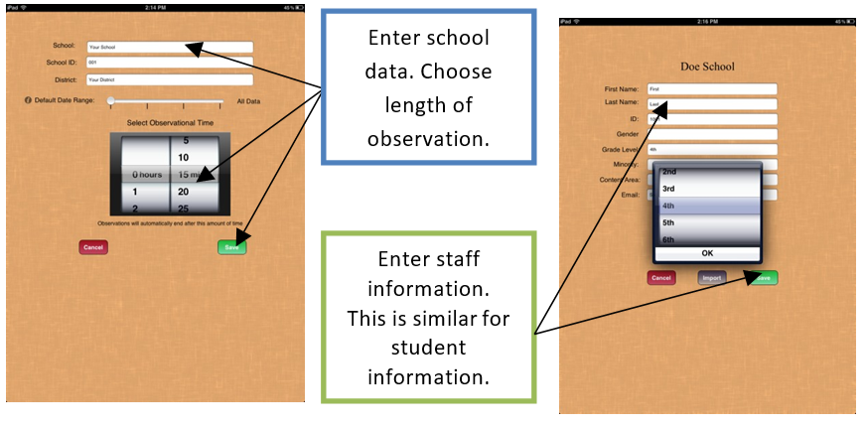

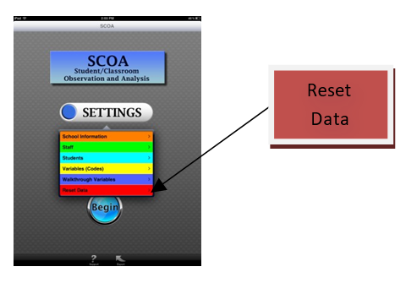

NOTE: RESET DATA will completely
erase all data entered and should
be used with caution.

Variables (Codes)
Instructional, teacher and student observation variables are programmed and ready for use. For a definition of each of the variables, refer to the list of
variables at the end of the document. Variables (codes) are preprogrammed within four categories:
- instructional variables,
- teacher observation variables,
- student observation variables, and
- custom variables.

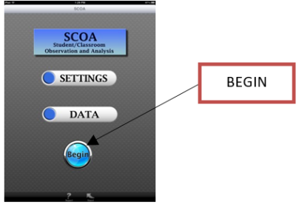
Procedures for a timed observation

- Press BEGIN from the main screen.
- Choose the type of observation to collect. Two types of timed observations are available:

OBSERVE WHOLE CLASS WITH TARGET STUDENT and
OBSERVE WHOLE CLASS WITHOUT TARGET STUDENT

- OBSERVE WHOLE CLASS WITH TARGET STUDENT: this is an observation with a target student, one identified specifically for observation. This observation format allows for the collection of student engagement variables during the observation.
- OBSERVE WHOLE CLASS WITHOUT TARGET STUDENT: this is an observation without a target student. It collects information on the teacher behavior, allowing for a rating of student engagement (using a sliding scale) upon completion of the observation.
- You will be prompted to choose a SCHOOL and a TEACHER to observe. You will be further prompted to choose a STUDENT if this information was entered.
- Observations can be collected in one minute increments. The time of the collection is determined when the school data is entered. Note: if you want to change the observation time, return to the SETTING, SCHOOL, CHOOSE the SCHOOL and adjust the timer.
- As soon as the school is chosen the timing will begin. If you wish to pause the overall timer. Press stop as soon as the screen appears.
- At the end of the timer, the device will prompt you to enter Quick Notes, provide a Level of Student Engagement (if there is no target student) using a sliding scale, and SAVE. If you choose to end a session before the timer, press SAVE and you will be asked if you want to SAVE the observation.
- Saved files are on the device used. The observation results can be viewed by pressing the
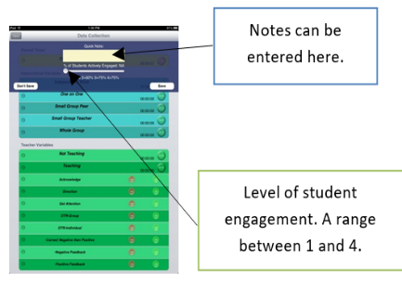
DATA key from the main page. Choose the SCHOOL, TEACHER or STUDENT and the DATE of the specific observation to view the results. At the top right is an envelope. Pressing the envelope allows the results to be sent via an email to the teacher observed. Note: the email address will automatically enter if provided under the teacher settings or can be entered manually. The email function will only work if the device settings are entered to send and receive email.
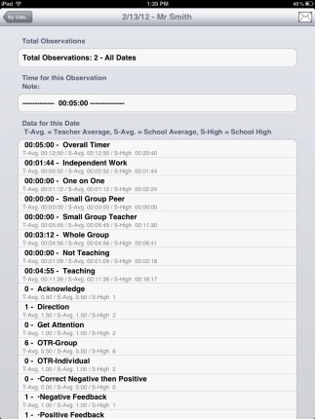
Summary of observation findings.
Envelope opening an email. The document will be included in the email.

Walkthrough observations

The walkthrough function allows the user to collect frequency of an observed topic throughout the building. The options with this collection type include YES-­‐ observed, NO-­‐not observed, or NA-­‐not applicable.

- Begin under SETTINGS and touch WALKTHROUGH.
- Press add ‘+’ and enter the name of the behavior or topic you would like to observe. Press SAVE.
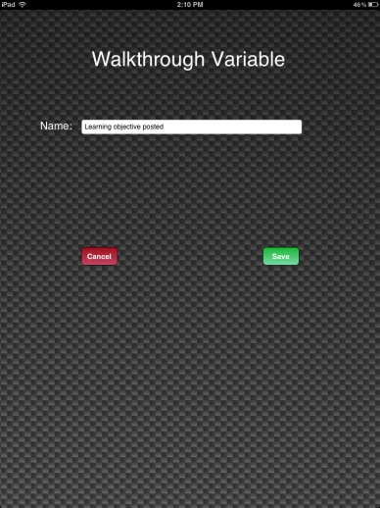
Press SAVE
when finished.
Walkthrough descriptor

- To collect data using a walkthrough approach, press BEGIN and WALKTHROUGH. Choose the SCHOOL and any or all of the VARIABLES you are choosing to observe.
- Press GO
- Collect using the options of YES-­‐observed, NO-­‐not observed, or NA-­‐not applicable
- SAVE the file when all WALKTHROUGH variables are complete.

- To observe the findings, press DATA from the main page, WALKTHROUGH DATA, the SCHOOL and the VARIABLE/DATE you would like to view. You will see the sum of each category
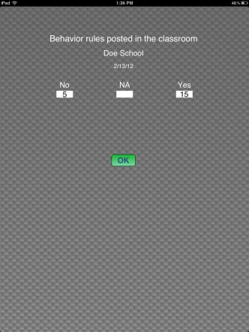
Result totals are displayed.

Information during coding

Encountering a question regarding codes during an observation can be addressed by pressing the italics “i” to the left of the code. This will bring up a definition of the code.
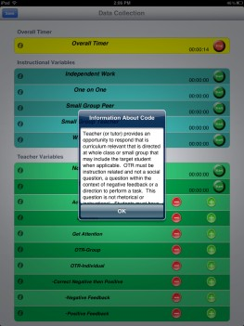
A text box appears with a definition of the variable.

Codes
Code Definitions
Codes are programmed within the application. Definitions of codes are written with specificity allowing teacher and student behaviors to be recorded with precision and accuracy by multiple observers. The codes reflect student and teacher behaviors that are observable and measurable. The following code definitions are used when recording classroom teacher and student behavior:
Code Description | Short Term | Type of Data  Collected | Code Definition | Example
Teacher  teaching | Teaching | Percent of | Teacher is engaged in instruction by explaining a concept, demonstrating a principle, or modeling a skill or activity to the group. The teaching must be academic and furthering the lesson/objective of class. Ask yourself, “Are students receiving  content instruction?” | -­‐ Lecture  -­‐ Describe steps in  an assignment  -­‐ Demonstrate a  procedure
 |  | observation
Teacher not  teaching | Not Teaching | Percent of  observation | Teacher is not engaging students and is involved in independent task with no interaction with students. Use “Not-­‐teach” when teacher is  talking off-­‐topic. | -­‐ Teacher working at  desk  -­‐ Conversation  unrelated to content
Teacher  provided  opportunities  to respond  (group) | OTR Group | Frequency  count | Teacher provides an opportunity to respond that is curriculum relevant and that is directed at whole class  or small group. OTR must be instruction related and not a social  question, a question within the context of negative feedback, or a  direction to perform a task. This question is not rhetorical. Students  must have to think about answering the question. OTR must be relevant to curriculum. | -­‐ “Who can tell me?”  -­‐ “What are reasons  for the…?”  -­‐ “Describe your  solution.”
Teacher provided opportunities to respond (Individual) | OTR  Individual | Frequency count | Teacher provides an opportunity to respond that is curriculum relevant toward a specific individual. OTR must be instruction related and not a social question, a question within the context of negative feedback, or a direction to perform a task. This question is not rhetorical. Students  must have to think about answering the question. | -­‐ “Sam, what is your answer?”  -­‐ “Kate, how did you answer the problem?”  -­‐ “Thomas, describe your idea for the project.”

Positive  Feedback | Positive  Feedback | Frequency  count | Teacher response to the  student that the individual behavior or response is correct. | -­‐ “Yes!”  -­‐ “That is correct”  -­‐ “Great job.”
Negative Feedback | Negative Feedback | Frequency count | Teacher response to the student that the individual behavior or response is incorrect. | -­‐ “No!”  -­‐ “Stop”  -­‐ “That is wrong”
Correction | Correct Negative than Positive | Frequency count | Teacher response to the student that the behavior or response is not correct and includes a statement of the desired behavior or  response. | -­‐ “No, Oliver, do not throw the paper from your desk.  Walk over to the trash and place the  paper into the basket.”
Directions | Direction | Frequency count | Teacher provides a command to the student that is not related to content or curriculum. | -­‐ Please put your books away.  -­‐ Please line up to  move down the hallway.
Acknowledge | Acknowledge | Frequency count | Teacher acknowledges a student request for attention. The code is only used when the  student solicits teacher attention first. | -­‐ “Did you have a question?”  -­‐ “Yes, Caroline, what is your idea?”  -­‐ Teacher points to the raised hand

Get Attention | Get attention | Frequency count | Student solicits the teacher’s attention. | -­‐ Raised hand  -­‐ Call of teacher’s name  -­‐ Call out
Student  down time | Down-­‐time | Percent of  observation | There are no academic  expectations of the  students observed. | -­‐ Teacher seated at  desk working on  computer  -­‐ Teacher outside of  the classroom
Student  off-­‐task | Off-­‐task | Percent of  observation | Student is neither  actively engaged nor  looking at the teacher  but is not disrupting the  class in any way (no  negative behaviors).  Sleeping | -­‐ Texting  -­‐ Working on  another subject  -­‐ Turned away from  the task and reading  a novel
Student  passive  engagement | Pass  Eng | Percent of  observation | Student is passively | -­‐ Eyes following the
 |  |  | attending to instruction | teacher
 |  |  | by orientation to teacher | -­‐ Watching a
 |  |  | or peer if appropriate. | demonstration
Student  active  engagement | Act Eng | Percent of  observation | Student is actively  engaging with instructional content via choral response, raising hand, responding to  teacher instruction, writing, reading, or otherwise completing assigned task. | -­‐ Reading to the  group  -­‐ Writing a response  -­‐ Creating a visual  -­‐ Completing an  experiment  -­‐ Solving a problem  with manipulatives
Disruption | Disrupt | Frequency  count | Students displays a  behavior that disrupts  or has the potential to  disrupt the lesson | -­‐ Out of seat  -­‐ Yelling  -­‐ Talking to a peer  -­‐ Profanity  -­‐ Threats

Whole group  instruction | Whole Group | Frequency | Whole group is defined  as an activity that  involves the majority or  the entire class and in  which the teacher is  providing the students  with direct instruction  in academic content  (e.g., reading, math,  science lesson; social  skills group). | Listening to lecture  Guided practice  Observing a  demonstration
Small group  peer  instruction | Small Group  Peer | Frequency | Small group peer is  defined as participation  with one or more peers  without being teacher directed. During this activity, the students are discussing, collaborating, and  working together without the teacher. | Share answer with  partner  Lab work with  Partner  Cooperative group
Small group  peer  instruction | Small Group  Peer | Frequency | Small group peer is  defined as participation  with one or more peers  without being teacher directed. During this activity, the students are discussing, collaborating, and  working together without the teacher. | Share answer with  partner  Lab work with  Partner  Cooperative group
Small group  teacher  instruction | Small Group  Teacher | Frequency | Small group teacher is  defined as participation  in a group with a portion  of the students in the  class (at least one other  student) and the teacher. During this activity the teacher is providing the students in the group with  instruction | Teacher led direct  instruction to 4  students  Work station with a  teacher
Independent  work | Independent  Work | Frequency | Independent work is  defined when student sit  at his or her seat (on the  floor, at the blackboard)  and work independently. This may include reading,  completing worksheets,  taking a test, etc. | Worksheet  Reading  Computer use
One-­‐on-­‐one  instruction | One on one | Frequency | One on one is defined as  the student being  provided individual  direct instruction or  attention in academic  content by an adult. | -­‐ Teacher and  student completing a  task  -­‐ Correction of a  work product with  the teacher

Positive Classroom Behavior Supports (PCBS)
My Next Steps

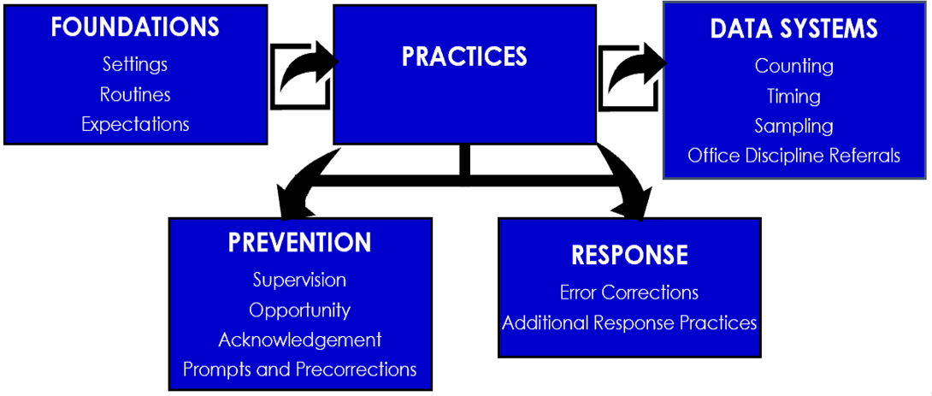

What Positive Classroom Behavior Supports will you put in place the first day of school?
What individualized PCBS will you practice and build fluency next year?

FOUNDATIONS

PREVENTION PRACTICES

RESPONSE PRACTICES

INDIVIDUALIZED PCBS

